LAB REPORT实验报告
Lab Title | Lab_01 |  |  |  | Lab No. | 1
Stud. Name | Jiang Yunxiang | Major | CST |  | Class
Student ID | 2022102330 |  | Date | 2023/2/24
Lab description/objectives:
Task1:
Modify example program 2.9.
Convert a Celsius temperature into its Fahrenheit equivalent.
Task2:
Calculate 10²+11²+...+20² by using formula 1²+2²+3²+....+n² = n(n+1)(2n+1)/6
Source code:
Task 1：
#include <stdio.h>
int main()
{
double celsius = 23.89;
double fahrenheit;
fahrenheit = 9.0 * celsius / 5.0 + 32;
printf("The Fahrenheit equivalent of %5.2f degrees Celsius\n",
celsius);
printf(" is %5.2f degrees Fahrenheit\n", fahrenheit);

return 0;
}
Task 2:
#include<stdio.h>

int calculate(int num)
{
return (num * (num + 1) * (2 * num + 1)) / 6;
}
int main()
{
int one_to_nine, one_to_twenty, ten_to_twenty;
one_to_nine = calculate(9);
one_to_twenty = calculate(20);
ten_to_twenty = one_to_twenty - one_to_nine;
printf("10^2 + 11^2 + …… + 20^2 equals %d", ten_to_twenty);
return 0;
}
Program outputs:
Task 1:
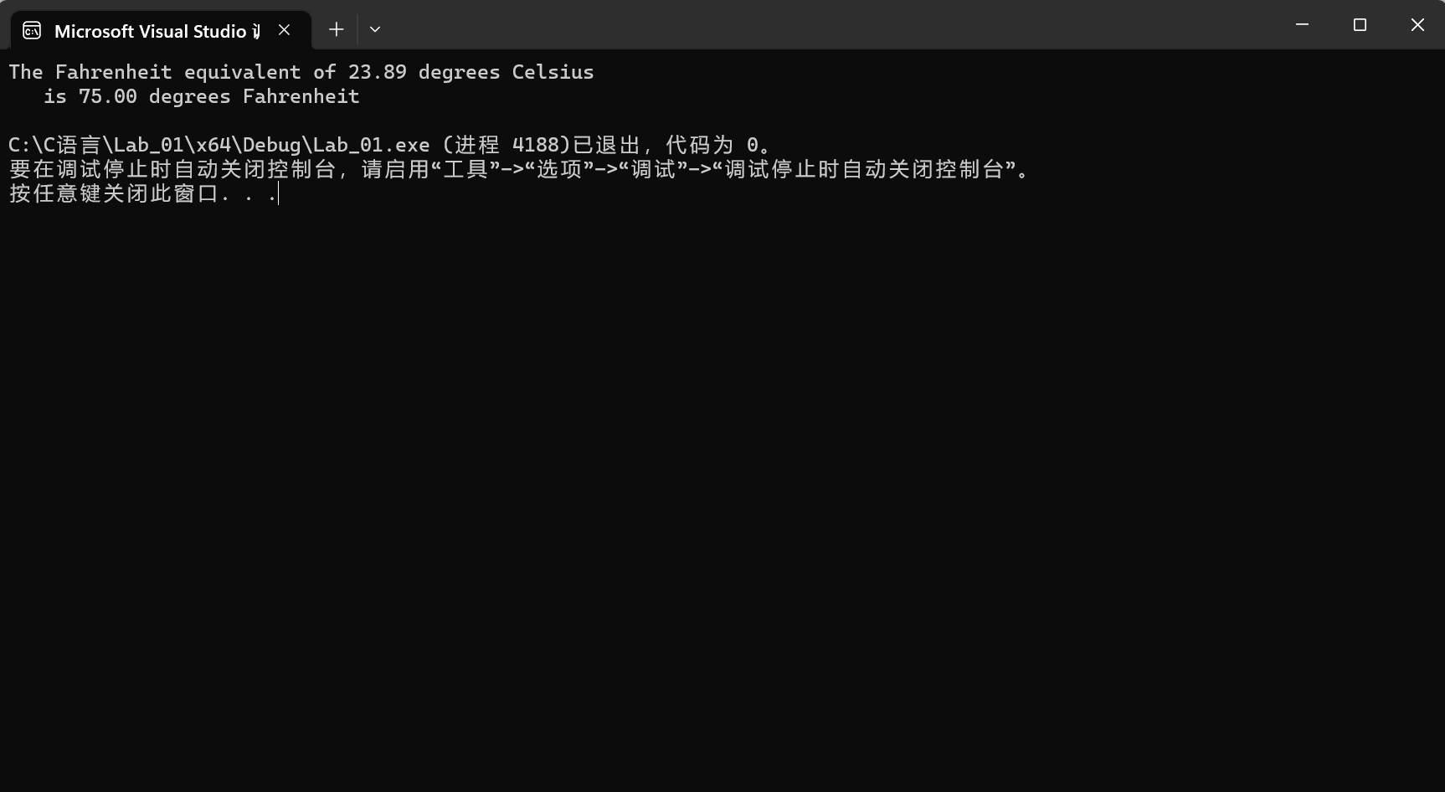
Task 2:
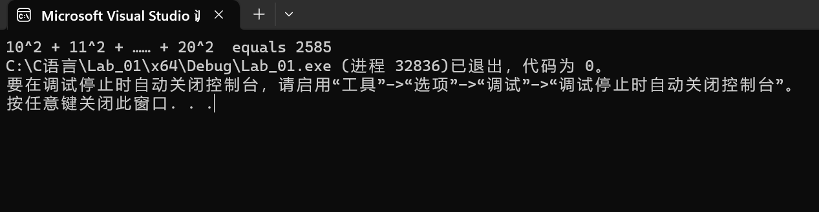
Discussion:
1．Most difficult parts
（What were the most difficult parts of your program to implement?）
It’s easy to finish the task but it may take some times for me to simplify the code and make it clean and more visual for people.
2．Bugs and/or Errors
(List all the program bugs/errors you encountered and how you corrected them.)
None

